Ayop, Jose P.

Agora Lapasan, West Coastal Road, Cagayan de Oro City, 9000

09682094507| joeayop@gmail.com

June 09, 2022

VP Jimmy P. Arco

Head LBP

Cagayan de Oro City Lending Center

2nd Floor Landbank Velez, Cagayan de Oro City

Dear Mr. Arco:

Greetings!

Having seen your job posting indicating that you are looking for a responsible, experienced driver to join your team, I, Jose P. Ayop, would like to express my interest in applying as a driver.

I have over three years of experience in driving delivery, and I am confident I could be a great addition to your team. I currently work as a freelance FoodPanda rider for more than a year now and before that, I have experience in being contracted as a courier for delivering packages/heavy items to all parts of Mindanao. I have experience in long-distance driving, as well as short-distance driving, and did so with the utmost safety on the road. Throughout my career, I have taken pride in my ability to offer courteous, reliable service. I believe that with my skills and experience as a driver, I would be a fantastic addition to your team. If you are so inclined, I would jump at the opportunity to visit you for an interview. With that, I have enclosed my curriculum vitae, professional driver’s license, and transcript of records for your review.

I am looking forward to our future cooperation and thank you for your time and consideration.

Sincerely,

AYOP, JOSE P.

Applicant

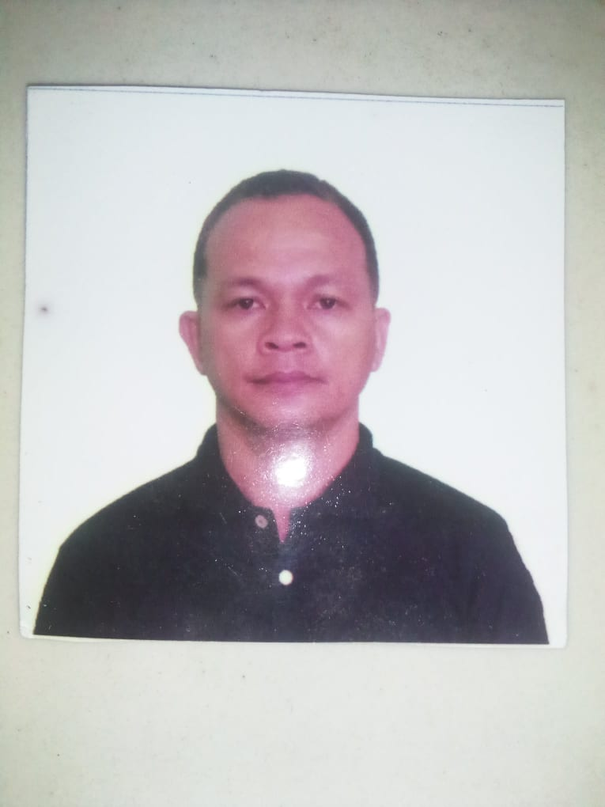AYOP, JOSE P.

Messenger/FoodPanda Rider

Agora Lapasan, West Coastal Road, Cagayan de Oro City, 9000

09682094507 | joeayop@gmail.com

***PROFESSIONAL EXPERIENCE***

**FoodPanda**

Freelance Rider, February 2021 – Present

* Deliver food at the fastest time possible
* Ensure timely delivery of the food while preserving the quality of the goods
* Perform vehicle inspections and maintenance prior to trips, every day.
* Provide excellent customer service to customers

**LandBank of the Philippines RDC**

Messenger, March 2019—Present

* Takes care and is in charge of the LBP warehouse Puntod, Cagayan de Oro City.
* Performs receiving, kitting, storage, tagging, and distribution of all items received
* Ensure spaces are prepared for the next day by mopping floors, dusting surfaces, and tidying furniture.

**FEM Tracking and Logistics Bulua**

Contractual Rider, December 2017- December 2018

* Operated Hyundai Starex van with medium to heavy loads across Mindanao—primarily transporting home appliances
* Plan travel routes in accordance with applicable traffic, transportation laws, regulations, and guidelines.
* Maintained accurate travel and inventory records
* Inspect vehicle before and after trips, noting mechanical problems.
* Detect and eliminate safety hazards during travel.

***EDUCATION***

**Tertiary**

Bukidnon State University, Malaybalay City

* Bachelor of Science in Business Administration major in Banking and Finance—**1997**

**Secondary**

Nuestra Seniora Del Pillar High School, Quezon City

* High School Diploma—**1993**

***LICENSE(S)***

* LTO Professional Driver’s License
* No DUIs or points

***ADDITIONAL SKILLS***

* Experience navigating with Google Maps
* Operating Equipment

***CHARACTER REFERENCE***

* **VP Lina K. Pacio**

Head WMBG LBP Velez CDO City

* **Reyvan Soco**

Driver WMBG LBP Velez CDO City

093116906658